CONFERENCE LOCATION:
DoubleTree by Hilton Hotel
16625 Swingley Ridge Road
Chesterfield, MO 63017
Local Phone: 636-532-5000

HOTEL RESERVATIONS:
Reduced rate is US$165 per night.
ACT EARLY – this special rate expires
on September 1, 2026.

Use the following link to make
your room reservations online:
https://group.doubletree.com/mbl32y

Or call the Hotel @ 636-532-5000
Mention Advanced Software Designs: Envision 2026 Block

Attendees are responsible for their
room, tax, and incidental charges.

HAVE A QUESTION?
CALL: Mary Zinkl or Ted Pliakos
Advanced Software Designs
636-532-6021

CANCELLATION & SUBSTITUTION:
Request for cancellation or substitution
must be made via mail, fax, or email to:

MAIL: Advanced Software Designs,
PO Box 647, Chesterfield, MO 63006
FAX: 636-532-2935
EMAIL: info@asdsoftware.com

Cancellation notice MUST be received
BEFORE September 5, 2026. A refund
(less $200 administrative fee) will be
mailed no later than October 5, 2026 .

NO refund request will be accepted
after September 5, 2026.

Get ENVISION 2026
information online at www.asdsoftware.com
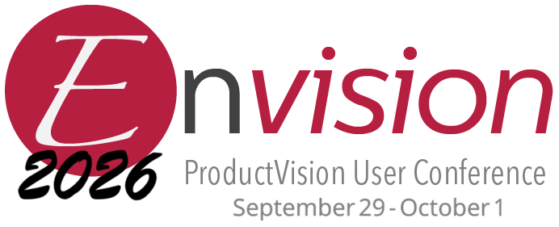

INSTRUCTIONS: Fill in the information below. Email the completed form to mary.zinkl@asdsoftware.com or fax to (636) 532-2935.
Completed Form and Payment or Purchase Order must be received
NO LATER THAN September 5, 2026
ATTENDEE INFORMATION
Full Name (as it will appear on your ID badge) Gender:
Male Female
Business Title:

Company:

Address:

City: State: Zip Code/Postal Code:

Country: Industry:

Phone Number (include area code and country code):

Email Address:

List Special Dietary Needs (if any):

The Directory of Attendees is available to all attendees. To be included in this directory, please check here:
CONFERENCE FEES
Payment received BY August 31, 2026: $1,195 USD per attendee.
Payment received AFTER August 31, 2026: $1,295 USD per attendee.
Amount Enclosed: $ USD

ACCEPTED PAYMENT METHODS:
- Send a check made payable to Advanced Software Designs with a copy of your registration form to:
Advanced Software Designs
PO Box 647
Chesterfield, MO 63006-0647
USA
- Or email a purchase order with a copy of your registration form to Mary:
mary.zinkl@asdsoftware.com
Purchase Order #:
Paid registrations will receive confirmation email.

